1. Check if a Directory Is Available
Save as check_directory.sh:
#!/bin/bash

DIR="/home/scripts/laxman/test"

if [ -d "$DIR" ]
then
echo "Directory exists: $DIR"
else
echo "Directory does not exist: $DIR"
fi
Execute:
chmod +x check_directory.sh
./check_directory.sh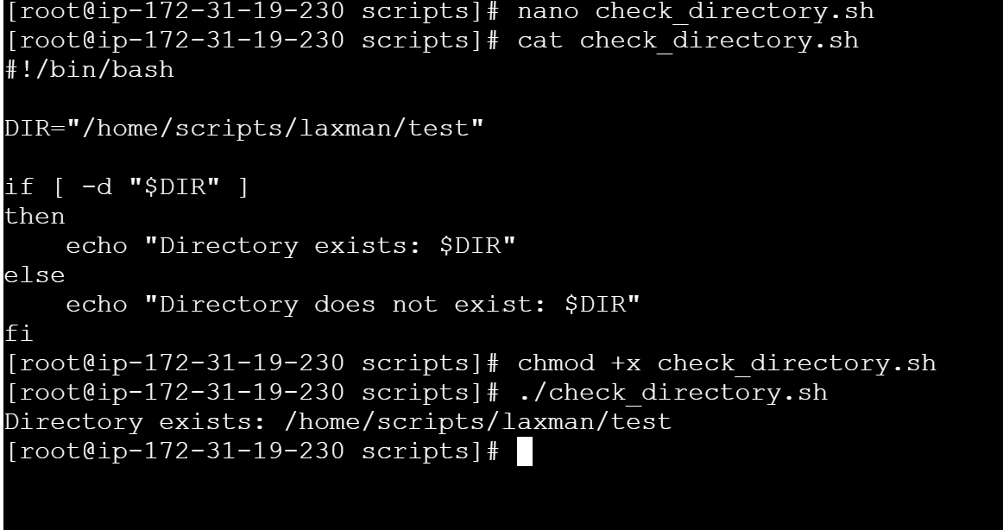

2. Create Multiple Files
Save as create_files.sh:
#!/bin/bash

DIR="/home/ec2-user/files"

mkdir -p "$DIR"

touch "$DIR/file1.txt"
touch "$DIR/file2.txt"
touch "$DIR/file3.txt"
touch "$DIR/file4.txt"
touch "$DIR/file5.txt"

echo "Multiple files created successfully."

ls -l "$DIR"
Execute:
chmod +x create_files.sh
./create_files.sh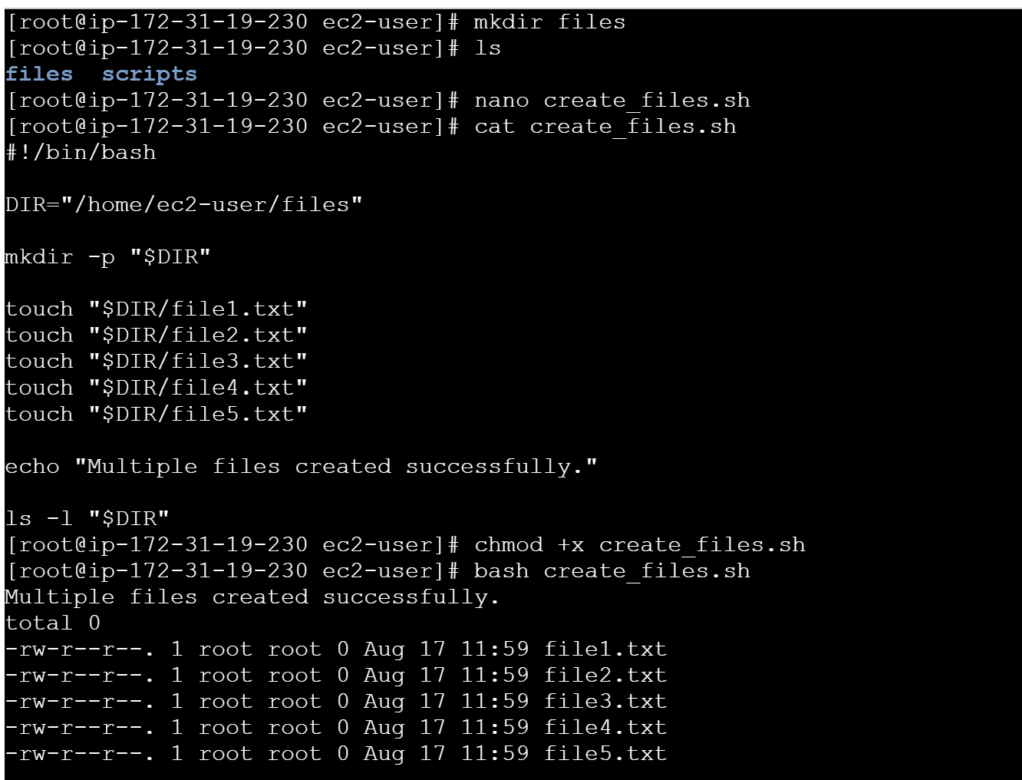

3. Take a Backup of a Directory
Save as backup_directory.sh:
#!/bin/bash

SOURCE="/home/ec2-user/test"
BACKUP="/home/ec2-user/backup"

DATE=$(date +"%Y-%m-%d_%H-%M-%S")

mkdir -p "$BACKUP"

if [ -d "$SOURCE" ]
then
tar -czf "$BACKUP/backup_$DATE.tar.gz" "$SOURCE"

echo "Backup completed successfully."
echo "Backup file: $BACKUP/backup_$DATE.tar.gz"
else
echo "Source directory does not exist: $SOURCE"
fi
Execute:
chmod +x backup_directory.sh
./backup_directory.sh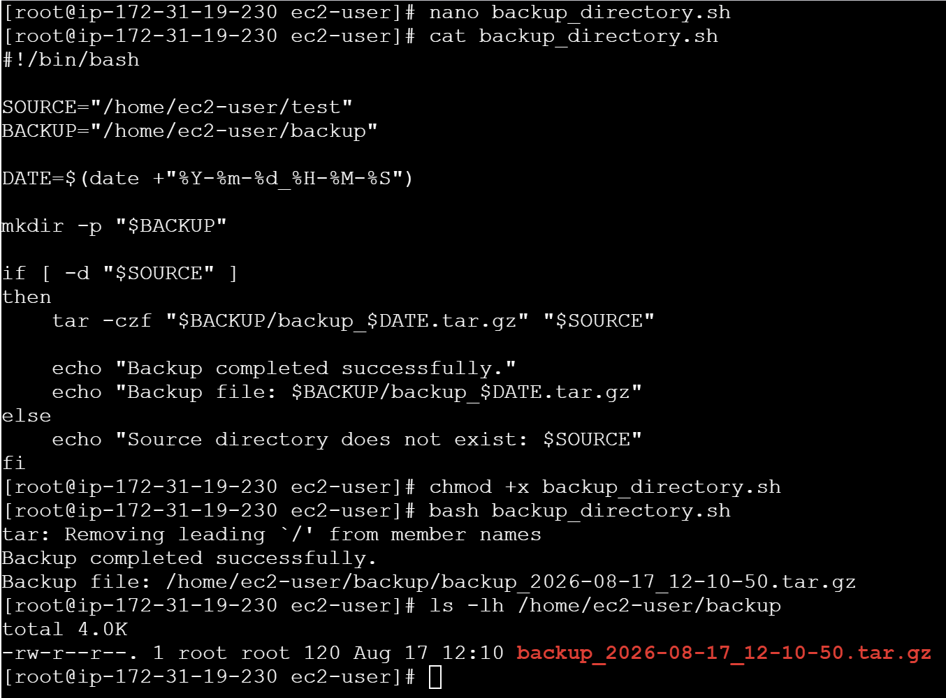

4. Install NGINX on an EC2 Server
Save as install_nginx.sh:
#!/bin/bash

echo "Updating system..."

sudo dnf update -y

echo "Installing NGINX..."

sudo dnf install nginx -y

echo "Starting NGINX..."

sudo systemctl start nginx

echo "Enabling NGINX at boot..."

sudo systemctl enable nginx

echo "Checking NGINX status..."

sudo systemctl status nginx --no-pager

echo "NGINX installation completed."
Execute:
chmod +x install_nginx.sh
./install_nginx.sh
Verify:
sudo systemctl status nginx 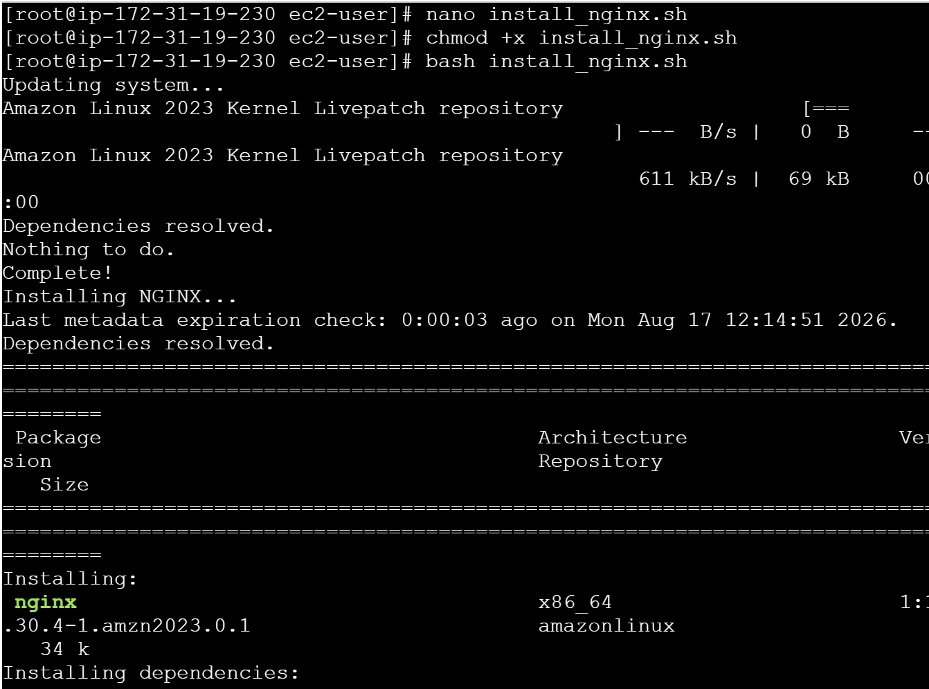 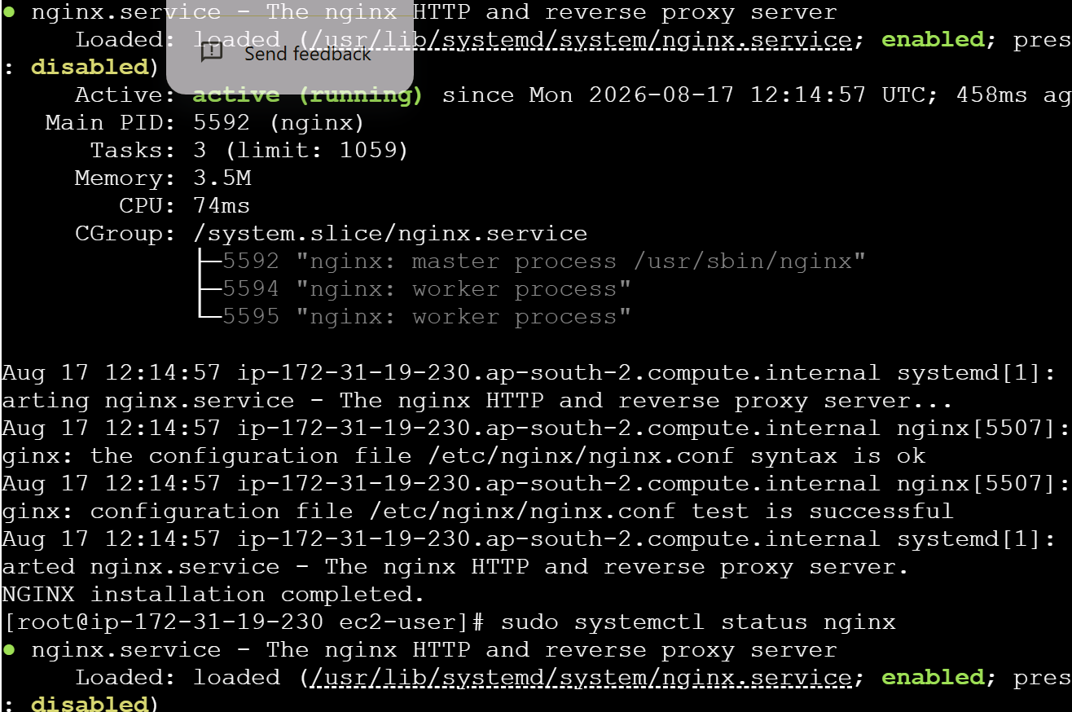 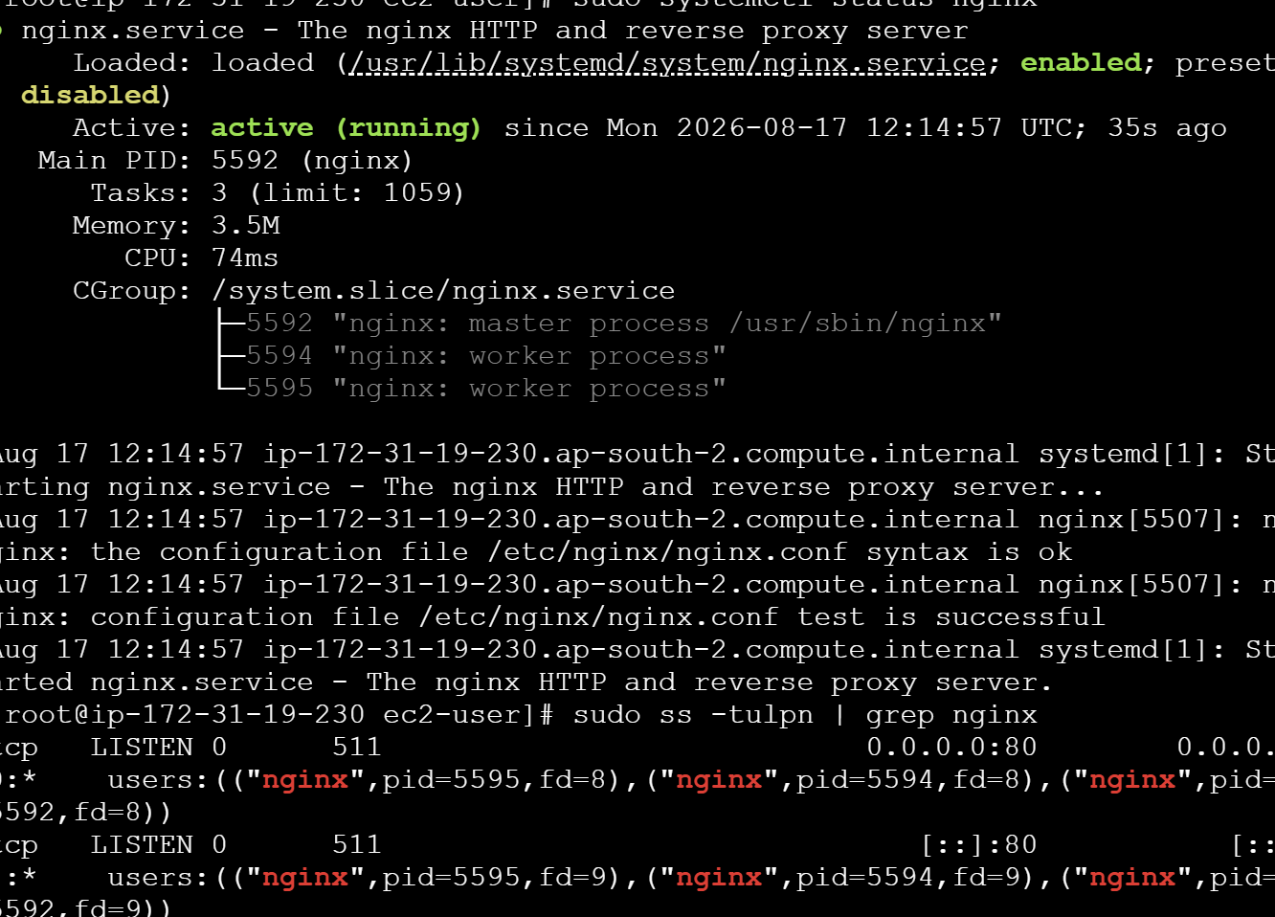 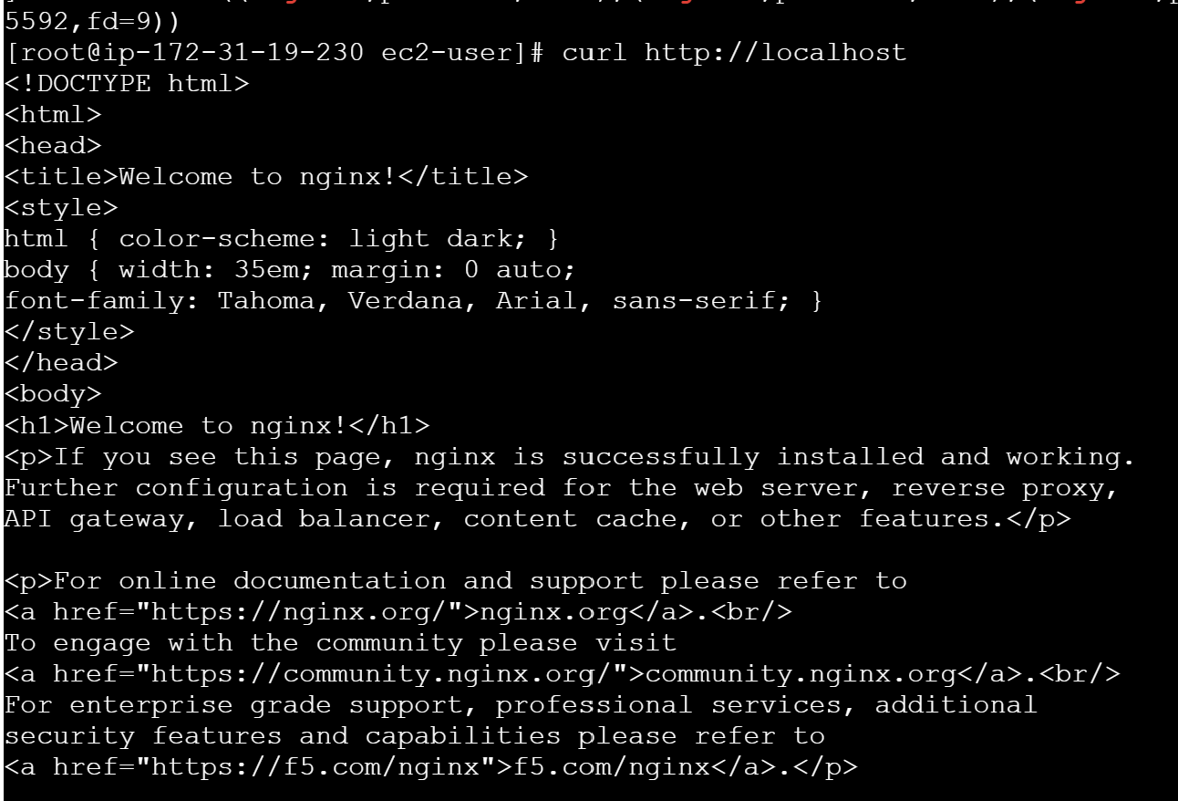 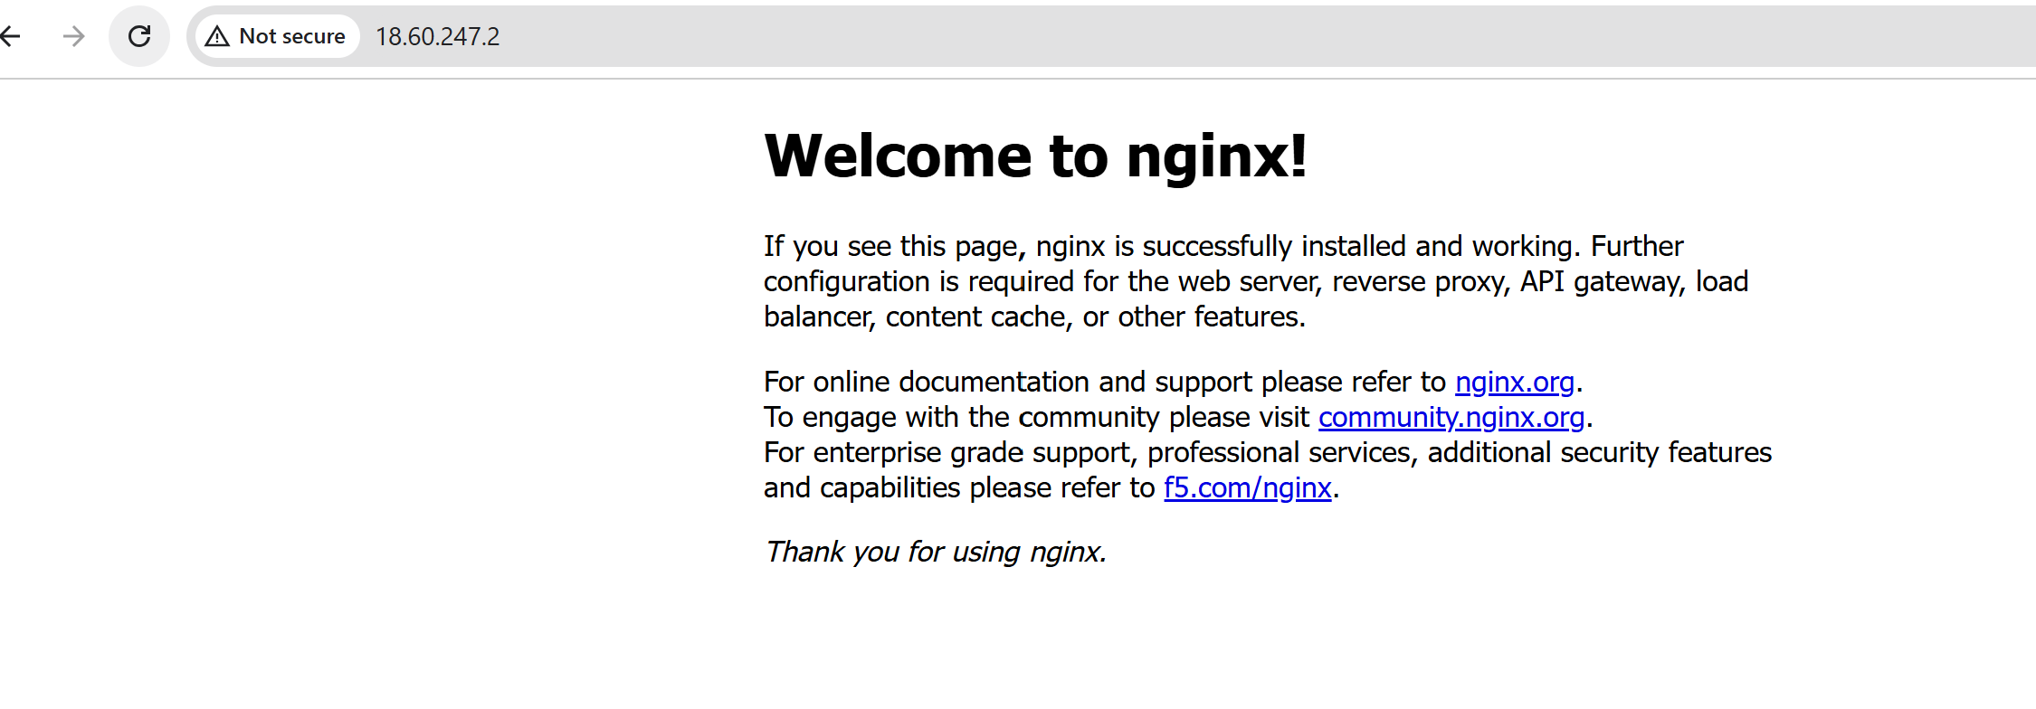
5. Install Apache Tomcat on an EC2 Server
This example installs Java 17 and Tomcat 10.
Save as install_tomcat.sh:
#!/bin/bash

TOMCAT_VERSION="10.1.57"
TOMCAT_DIR="/opt/tomcat"
TOMCAT_USER="tomcat"
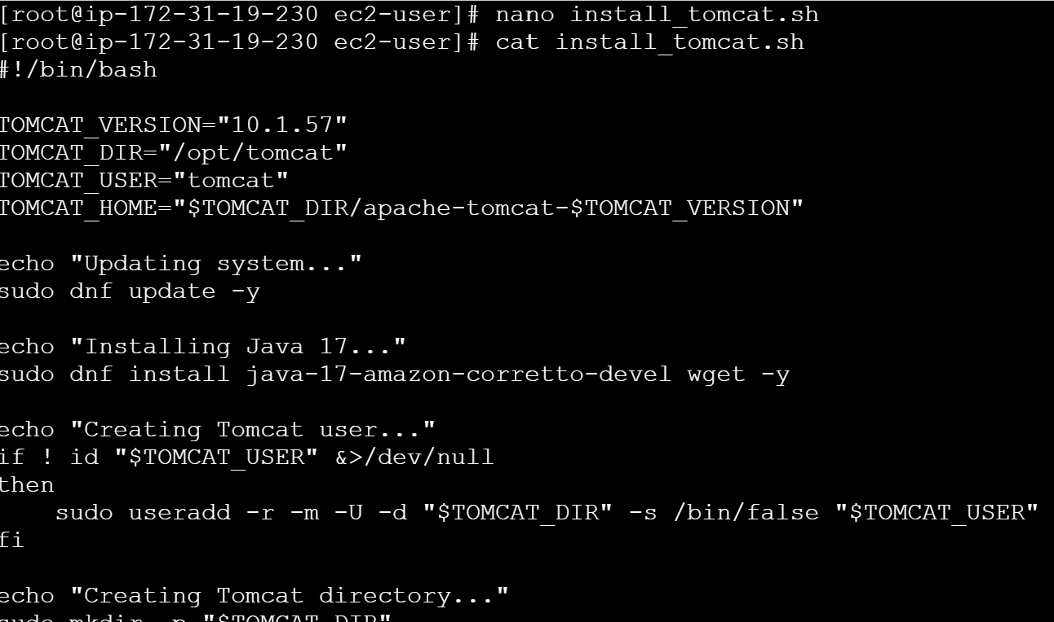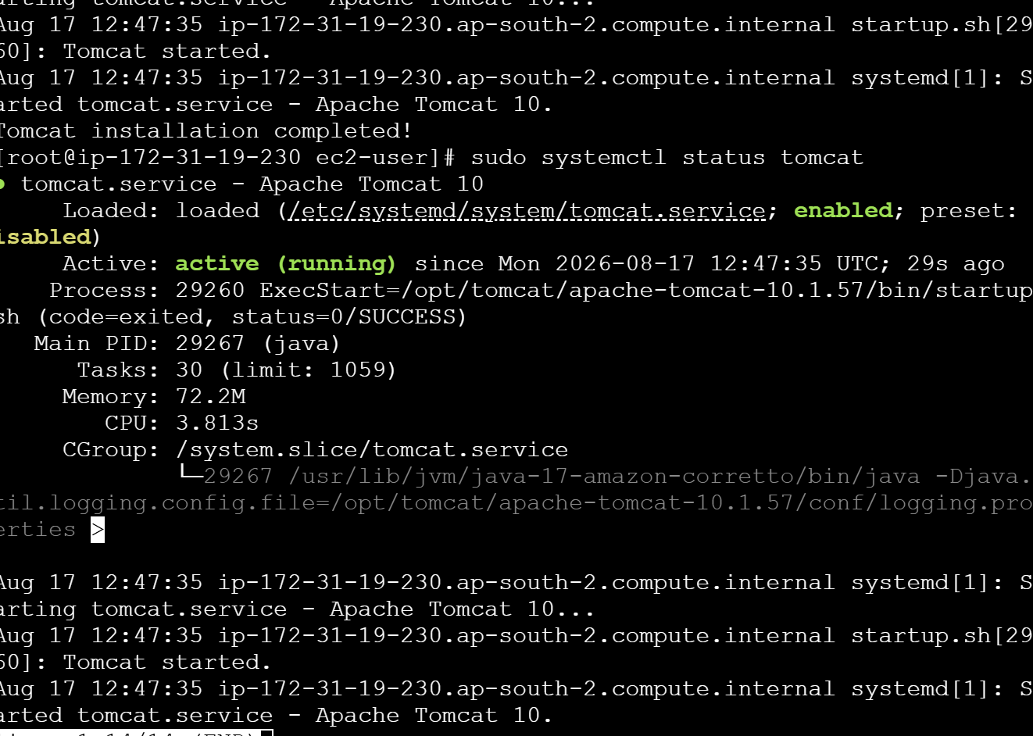
echo "Updating system..."

sudo dnf update -y

echo "Installing Java..."

sudo dnf install java-17-amazon-corretto-devel wget tar -y

echo "Creating Tomcat user..."

if ! id "$TOMCAT_USER" &>/dev/null
then
sudo useradd -r -m -U -d "$TOMCAT_DIR" -s /bin/false "$TOMCAT_USER"
fi

echo "Creating Tomcat directory..."

sudo mkdir -p "$TOMCAT_DIR"

cd /tmp || exit 1

echo "Downloading Tomcat..."

wget "https://dlcdn.apache.org/tomcat/tomcat-10/v${TOMCAT_VERSION}/bin/apache-tomcat-${TOMCAT_VERSION}.tar.gz"

echo "Extracting Tomcat..."

sudo tar -xzf "apache-tomcat-${TOMCAT_VERSION}.tar.gz" -C "$TOMCAT_DIR"

sudo mv "$TOMCAT_DIR/apache-tomcat-${TOMCAT_VERSION}" "$TOMCAT_DIR/tomcat"

echo "Setting permissions..."

sudo chown -R "$TOMCAT_USER:$TOMCAT_USER" "$TOMCAT_DIR"

sudo chmod +x "$TOMCAT_DIR/tomcat/bin/"*.sh

echo "Starting Tomcat..."

sudo -u "$TOMCAT_USER" "$TOMCAT_DIR/tomcat/bin/startup.sh"

echo "Tomcat installation completed."

echo "Tomcat URL:"
echo "http://YOUR-EC2-PUBLIC-IP:8082"
Execute:
chmod +x install_tomcat.sh
./install_tomcat.sh
Check Tomcat:
ps -ef | grep tomcat
Check port:
sudo ss -tulpn | grep 8082 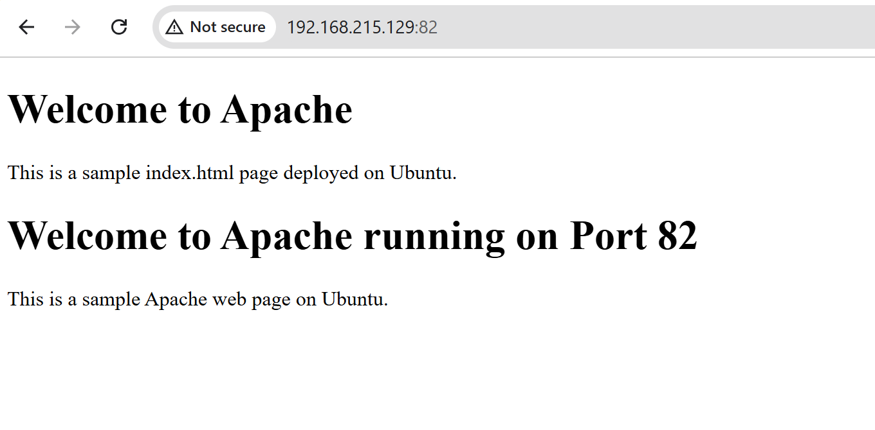
If the specified Tomcat version is no longer available on the Apache download server, change TOMCAT_VERSION to the currently available version.

6. Check NGINX Service and Start It if Not Running
Save as check_nginx.sh:
#!/bin/bash

SERVICE="nginx"

if systemctl is-active --quiet "$SERVICE"
then
echo "NGINX is already running."
else
echo "NGINX is not running."
echo "Starting NGINX..."

sudo systemctl start "$SERVICE"

if systemctl is-active --quiet "$SERVICE"
then
echo "NGINX started successfully."
else
echo "Failed to start NGINX."
fi
fi
Execute:
chmod +x check_nginx.sh
./check_nginx.sh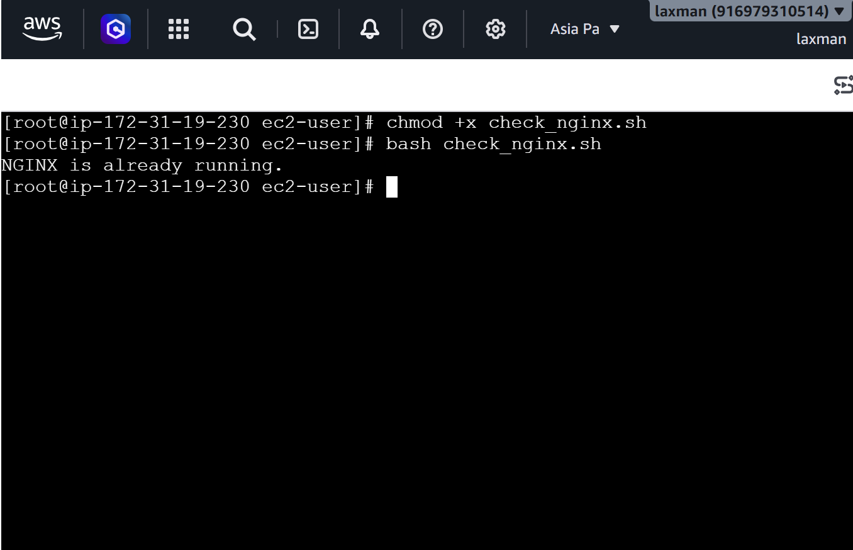

7. Bash Calculator
Save as calculator.sh:
#!/bin/bash

echo "===== Calculator ====="

read -p "Enter first number: " a
read -p "Enter second number: " b

echo "1. Addition"
echo "2. Subtraction"
echo "3. Multiplication"
echo "4. Division"

read -p "Enter your choice: " choice

case $choice in

1)
result=$((a + b))
echo "Result = $result"
;;

2)
result=$((a - b))
echo "Result = $result"
;;

3)
result=$((a * b))
echo "Result = $result"
;;

4)
if [ "$b" -eq 0 ]
then
echo "Error: Cannot divide by zero."
else
result=$((a / b))
echo "Result = $result"
fi
;;

*)
echo "Invalid choice."
;;

Esac
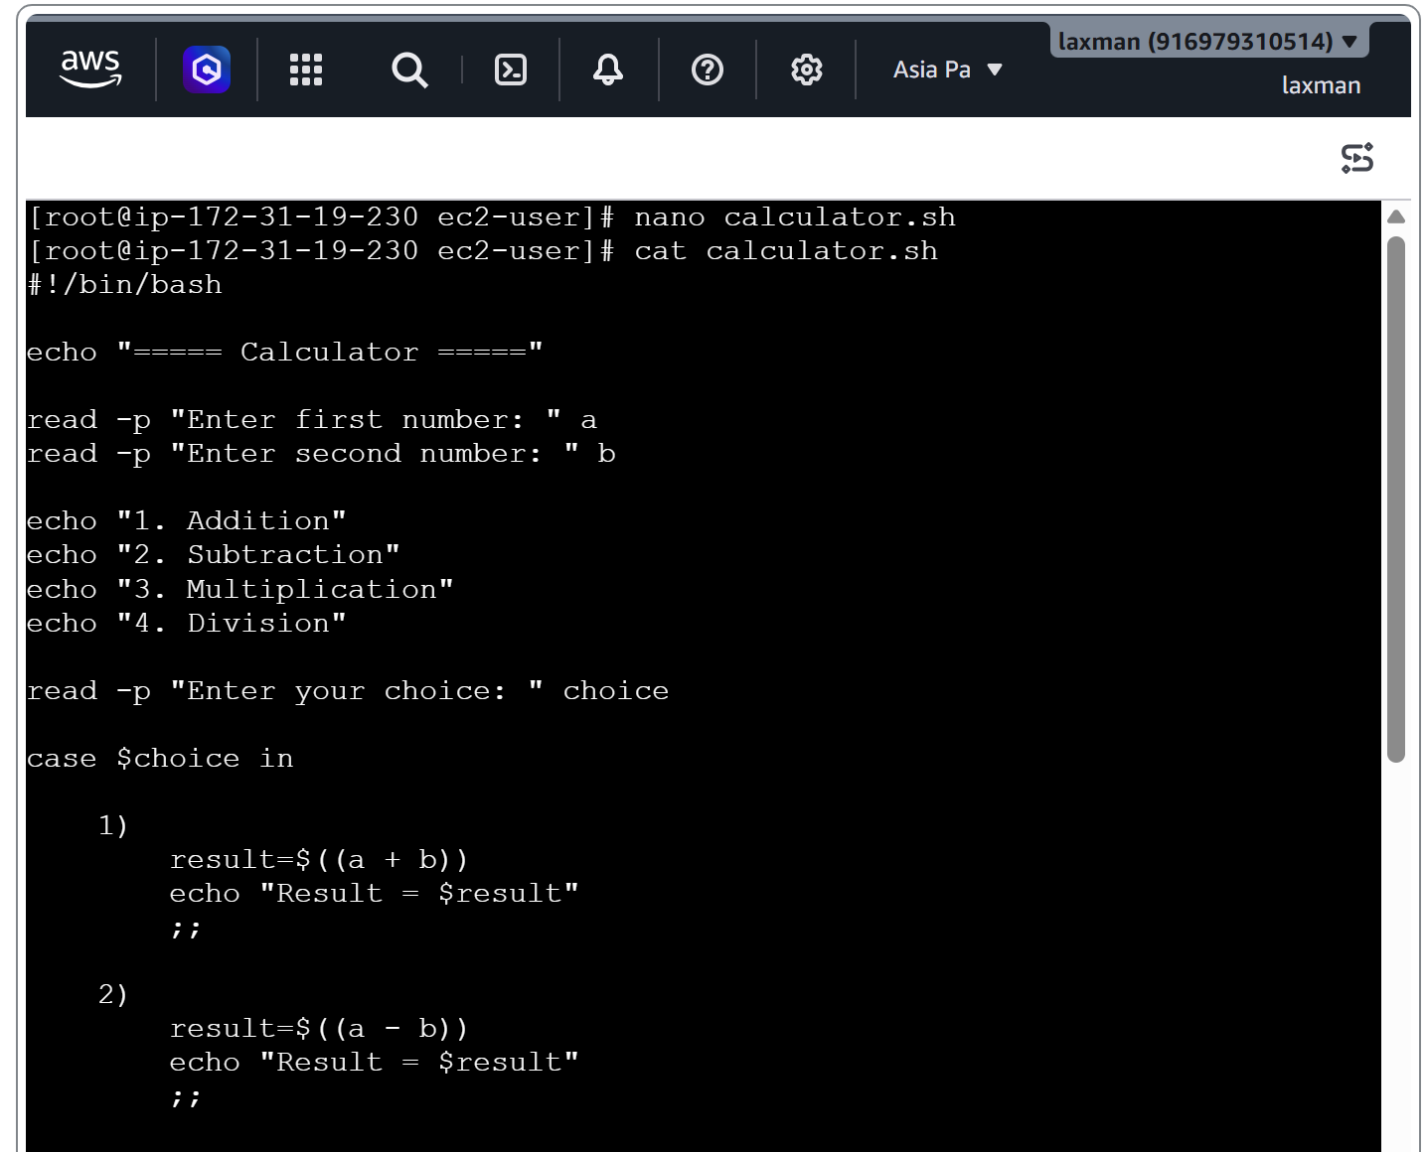
Execute:
chmod +x calculator.sh
./calculator.sh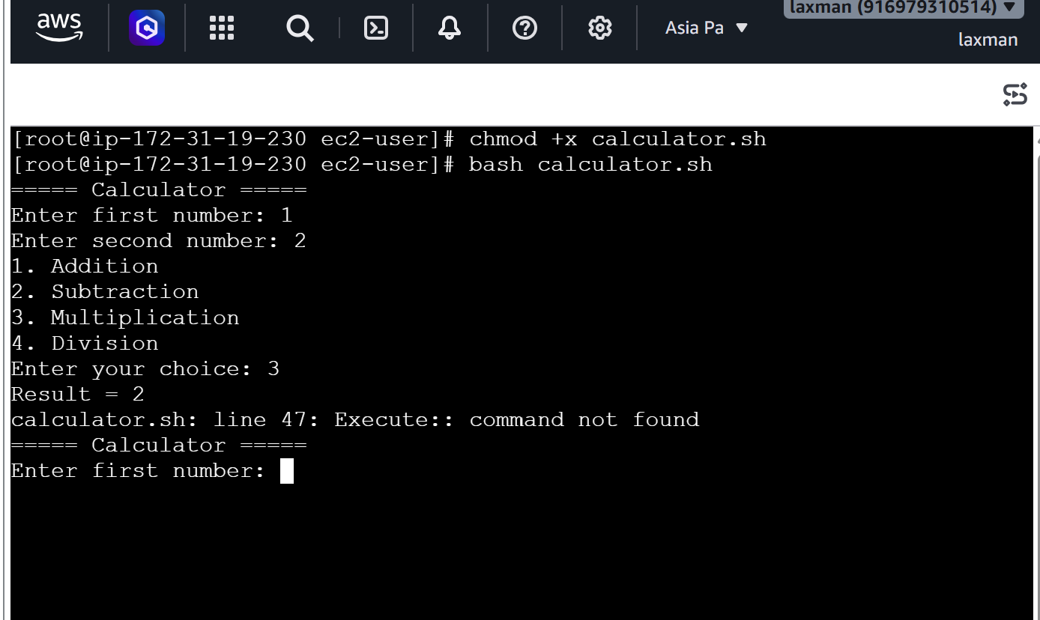

8. Check Directory and Create if It Does Not Exist
Save as create_directory.sh:
#!/bin/bash

DIR="/home/ec2-user/test"

if [ -d "$DIR" ]
then
echo "Directory already exists: $DIR"
else
echo "Directory does not exist."
echo "Creating directory..."

mkdir -p "$DIR"

echo "Directory created successfully: $DIR"
fi
Execute:
chmod +x create_directory.sh
./create_directory.sh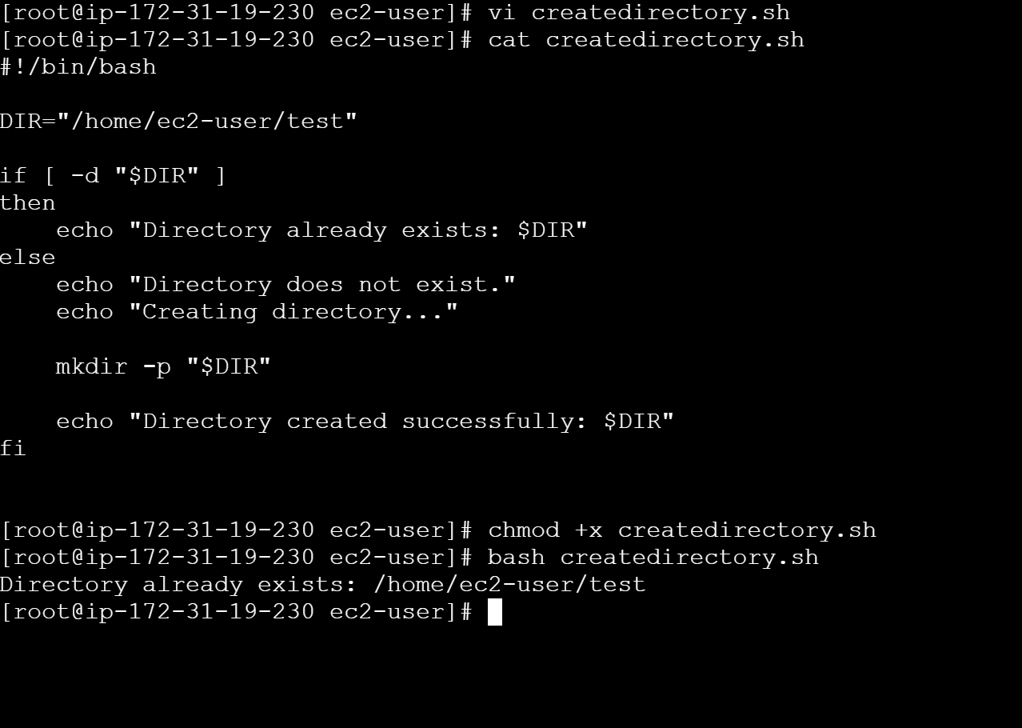

9. Delete the Last 3 Lines of a File
Save as delete_last_3_lines.sh:
#!/bin/bash

FILE="/home/ec2-user/test.txt"

if [ -f "$FILE" ]
then
LINE_COUNT=$(wc -l < "$FILE")

if [ "$LINE_COUNT" -ge 3 ]
then
head -n -3 "$FILE" > "$FILE.tmp"
mv "$FILE.tmp" "$FILE"

echo "Last 3 lines deleted successfully."
else
echo "File contains fewer than 3 lines."
fi
else
echo "File does not exist: $FILE"
fi
Execute:
chmod +x delete_last_3_lines.sh
./delete_last_3_lines.sh

Check the file:
cat /home/ec2-user/test.txt 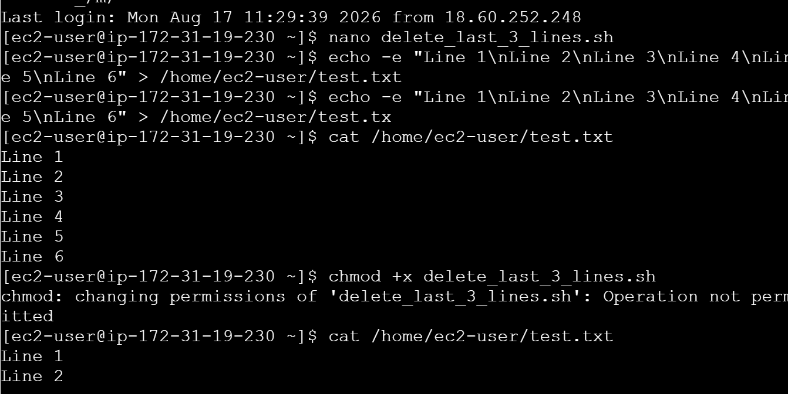 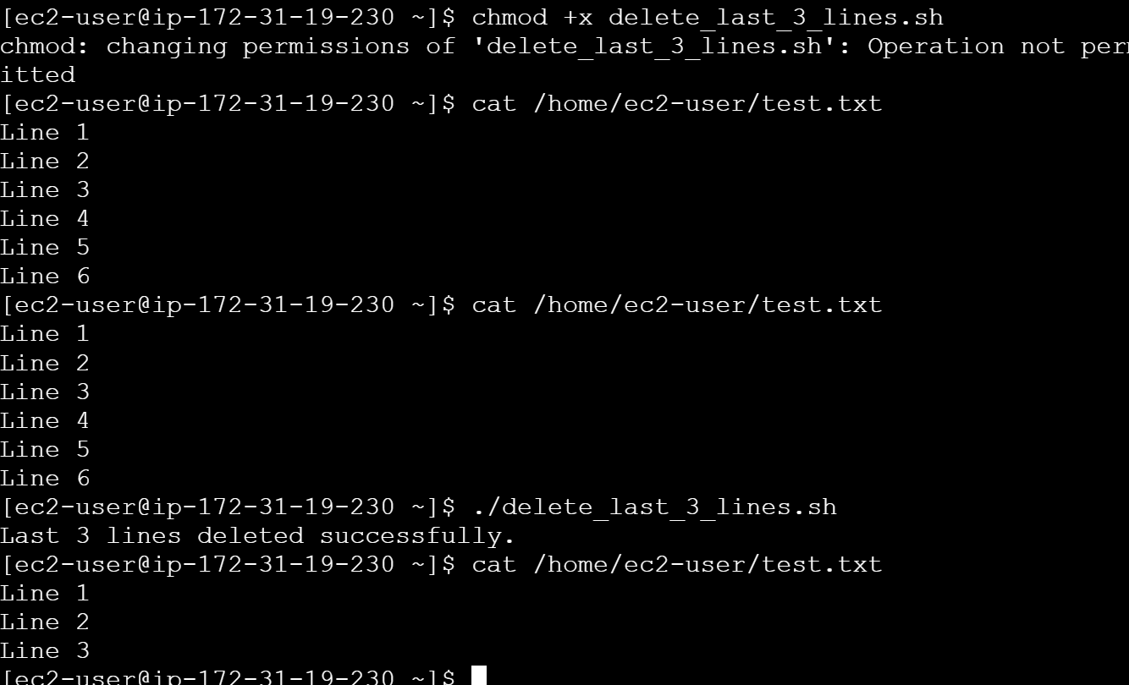

10. Monitor CPU Usage and Send Email if Above 80%
Save as cpu_monitor.sh:
#!/bin/bash

THRESHOLD=80
EMAIL="admin@example.com"

CPU_USAGE=$(top -bn1 | grep "Cpu(s)" | \
awk '{print 100 - $8}' | cut -d. -f1)

echo "Current CPU Usage: $CPU_USAGE%"

if [ "$CPU_USAGE" -gt "$THRESHOLD" ]
then
echo "WARNING: CPU usage is above $THRESHOLD%." \
| mail -s "CPU Usage Alert" "$EMAIL"

echo "Email notification sent."
else
echo "CPU usage is normal."
fi 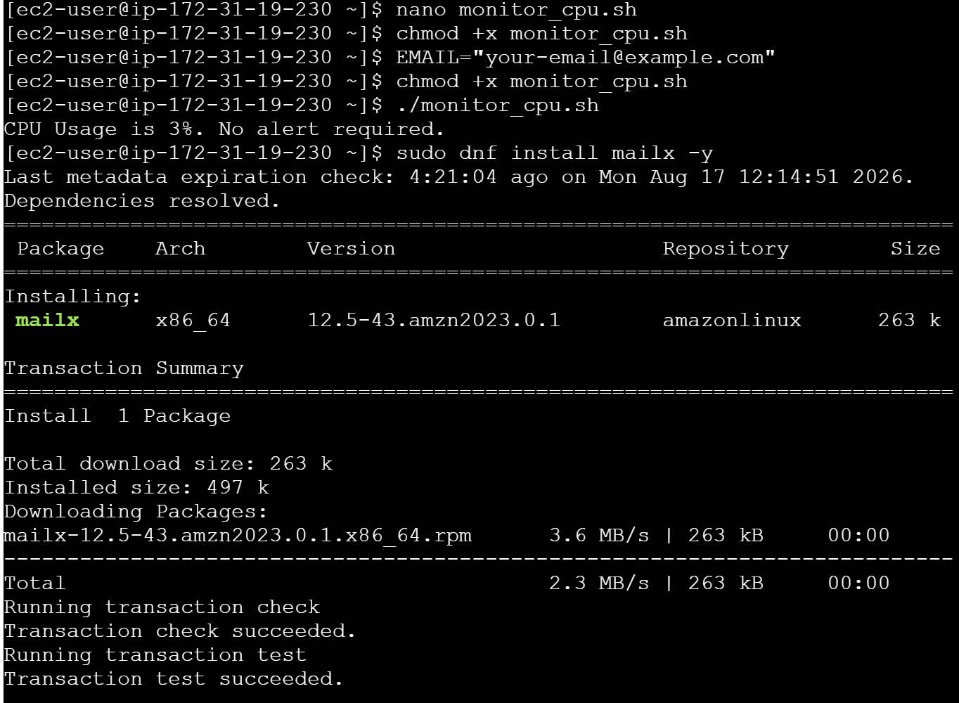
Install mail utility:
sudo dnf install mailx -y
Change:
EMAIL="admin@example.com"
to your actual email address.
Execute:
chmod +x cpu_monitor.sh
./cpu_monitor.sh
The mail command also requires a working mail/SMTP configuration on the EC2 instance. Installing mailx alone does not guarantee that email will be delivered.

11. Monitor Disk Space and Send Email if Above 80%
Save as disk_monitor.sh:
#!/bin/bash

THRESHOLD=80
EMAIL="admin@example.com"

DISK_USAGE=$(df / | awk 'NR==2 {print $5}' | sed 's/%//')

echo "Current Disk Usage: $DISK_USAGE%"

if [ "$DISK_USAGE" -gt "$THRESHOLD" ]
then
echo "WARNING: Disk usage is above $THRESHOLD%." \
| mail -s "Disk Usage Alert" "$EMAIL"

echo "Email notification sent."
else
echo "Disk usage is normal."
fi
Execute:
chmod +x disk_monitor.sh
./disk_monitor.sh
You can monitor a specific filesystem by changing:
df /
For example:
df /var 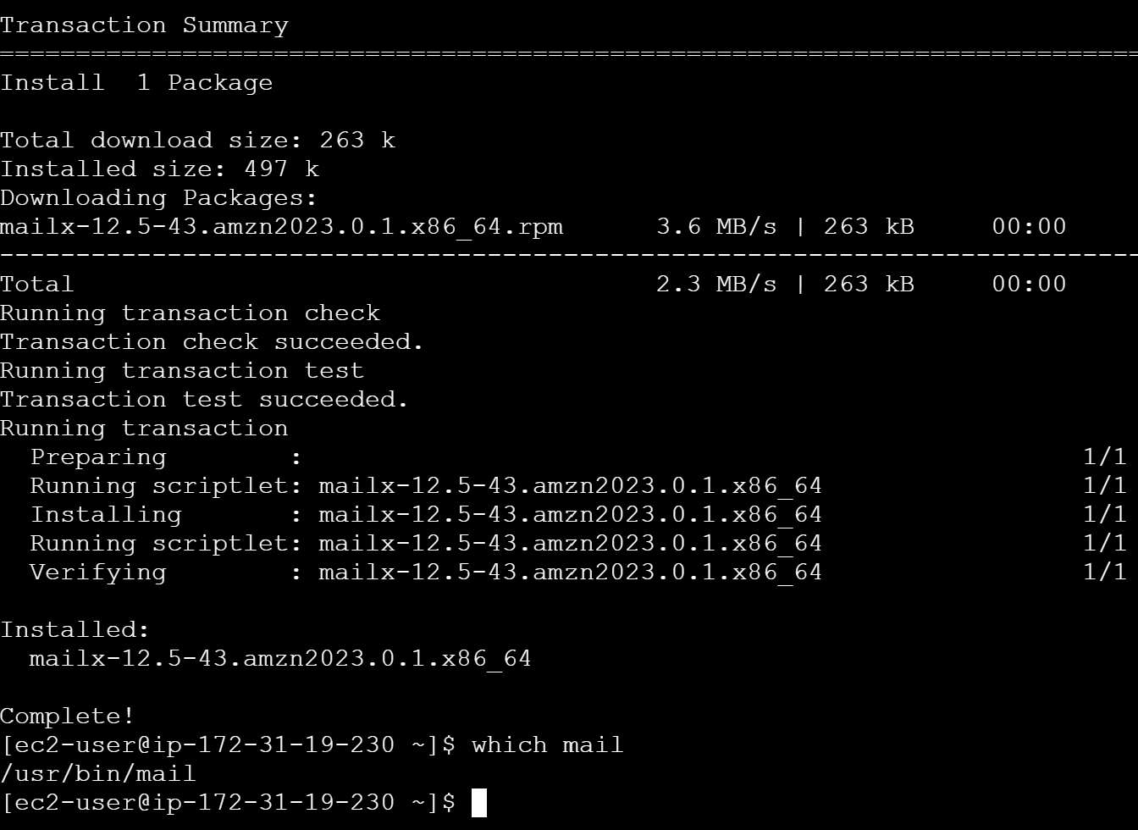

12. Monitor Memory Usage and Send Email if Above 80%
Save as memory_monitor.sh:
#!/bin/bash

THRESHOLD=80
EMAIL="admin@example.com"

MEMORY_USAGE=$(free | awk '/Mem:/ {
printf "%.0f", ($3/$2) * 100
}')

echo "Current Memory Usage: $MEMORY_USAGE%"

if [ "$MEMORY_USAGE" -gt "$THRESHOLD" ]
then
echo "WARNING: Memory usage is above $THRESHOLD%." \
| mail -s "Memory Usage Alert" "$EMAIL"

echo "Email notification sent."
else
echo "Memory usage is normal."
fi
Execute:
chmod +x memory_monitor.sh
./memory_monitor.sh 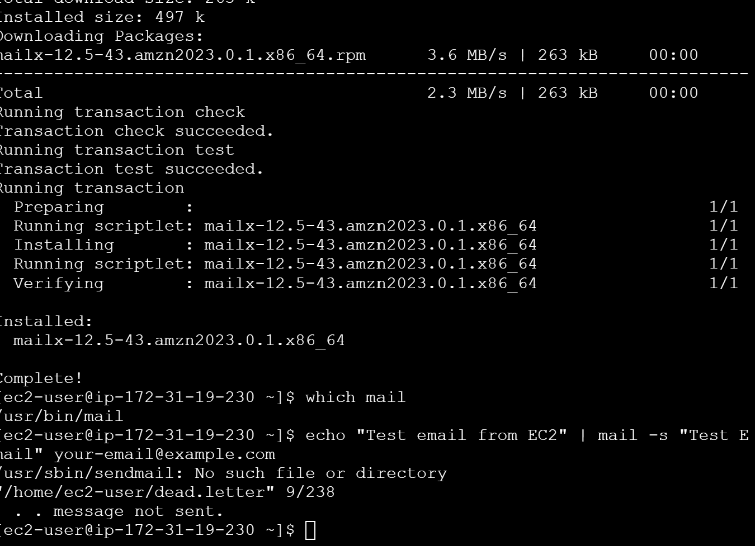

Exercise: Crontab Entries
Open the crontab:
crontab -e
The general format is:
MINUTE HOUR DAY-OF-MONTH MONTH DAY-OF-WEEK COMMAND 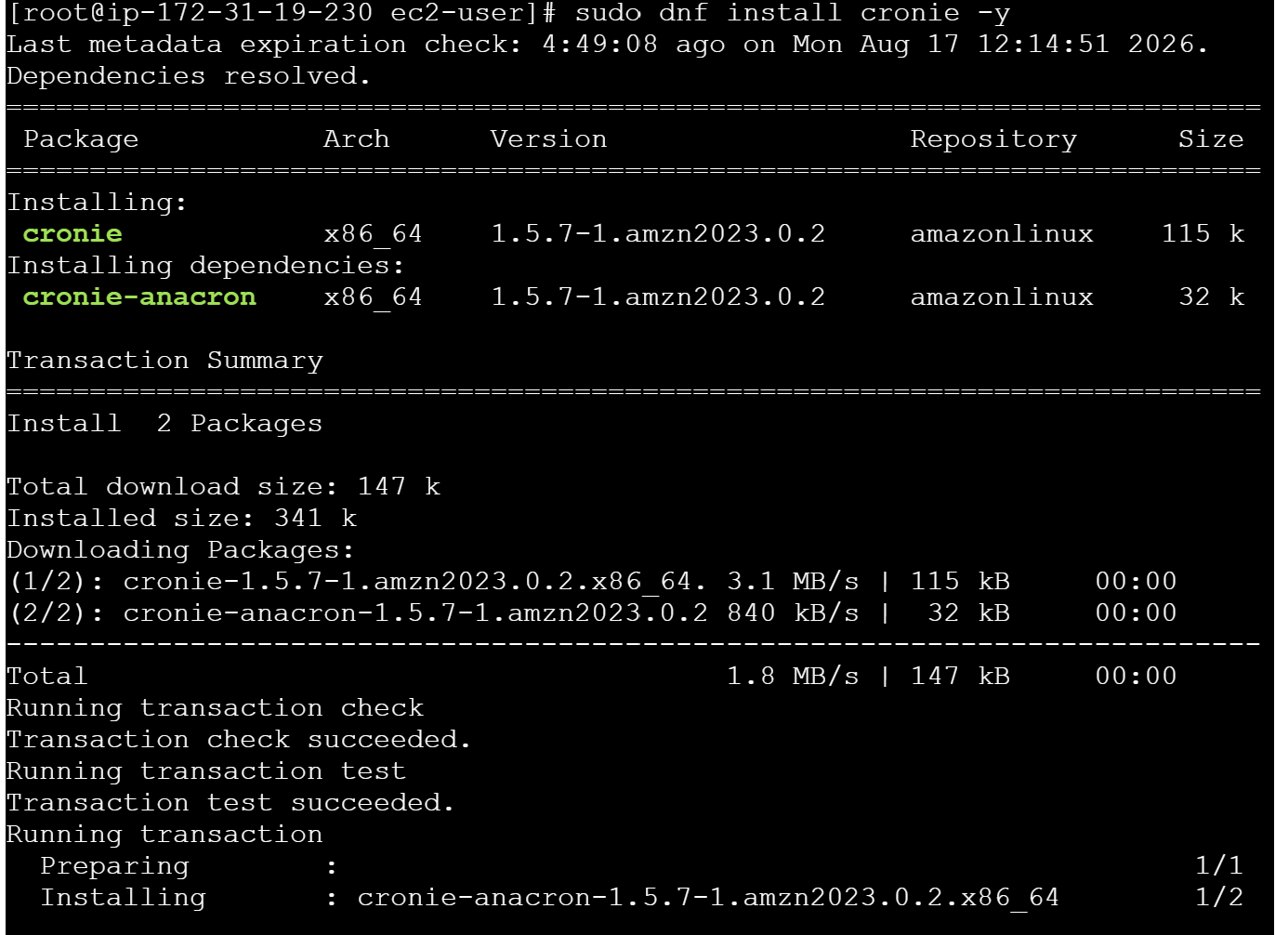 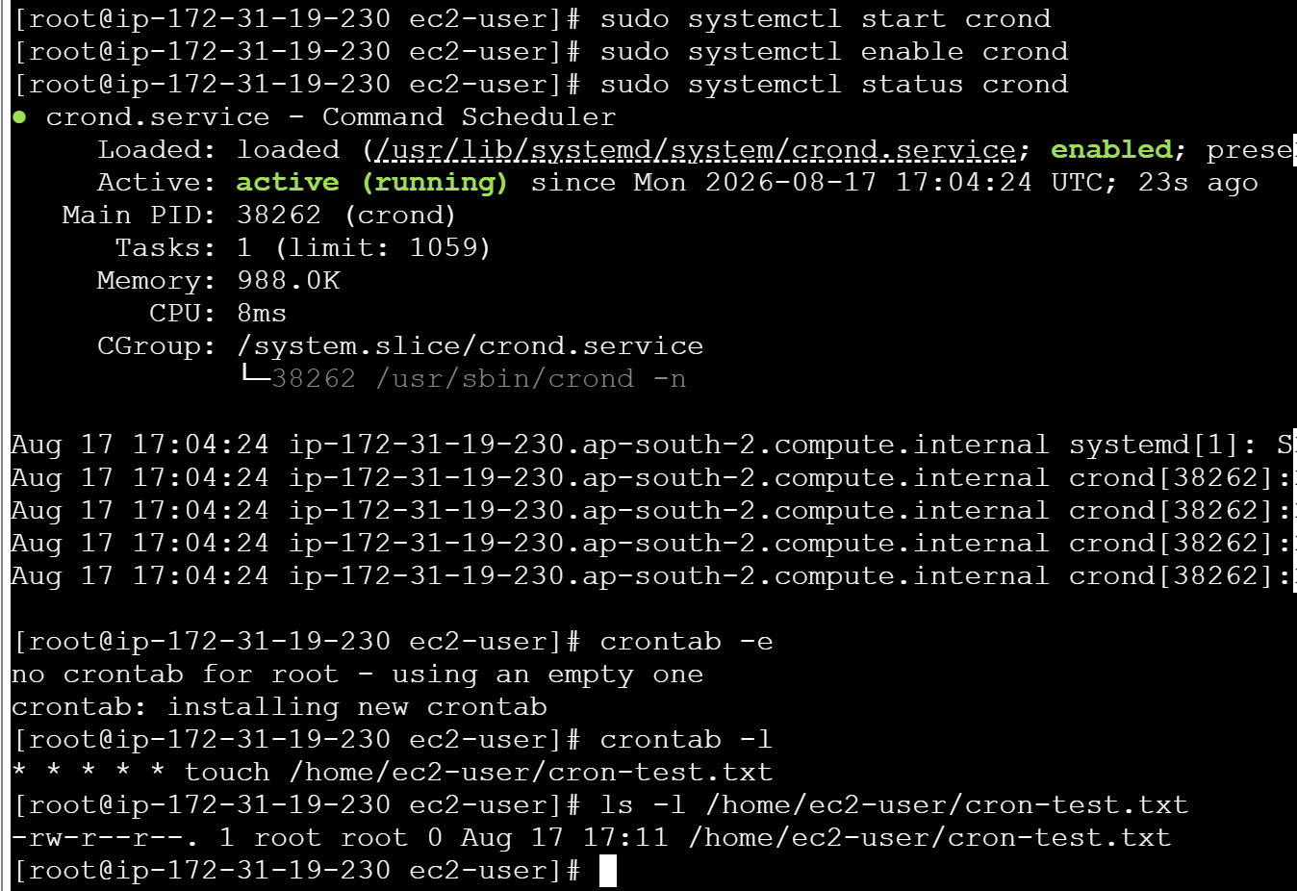

1. April 5th Midnight
April 5 at 12:00 AM
0 0 5 4 *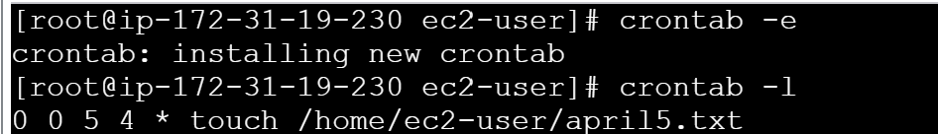

2. 5th of November, January, June if It Is a Thursday
January, June, or November and Thursday:
0 0 5 1,6,11 4
Here:
- 0 = minute
- 0 = hour
- 5 = 5th day
- 1,6,11 = January, June, November
- 4 = Thursday
In standard cron numbering, Sunday is 0, Monday 1, ..., Thursday 4.

3. At 05 and 27 Minutes of 9, 10, 11 Hours Every Day
5,27 9,10,11 * * *
This runs at:
09:05
09:27
10:05
10:27
11:05
11:27
every day.

4. 34 Minutes of 9th Hour on 15th August
34 9 15 8 *
This runs:
August 15 at 09:34 AM

5. Every Midnight
0 0 * * *
Runs every day at:
12:00 AM

6. Every Weekend — Saturday Night at 11:59 PM
59 23 * * 6
This runs every Saturday at:
11:59 PM

7. After Every Reboot
For a job that should run once after every system reboot:
@reboot /home/ec2-user/script.sh
For example:
@reboot /home/ec2-user/check_nginx.sh
Make sure the script is executable:
chmod +x /home/ec2-user/check_nginx.sh

Complete Crontab Example
If you want to put all the exercises into one crontab, it can look like this:
# 1. April 5th at midnight
0 0 5 4 /home/ec2-user/script1.sh

# 2. 5th of January, June, November if Thursday
0 0 5 1,6,11 4 /home/ec2-user/script2.sh

# 3. 05 and 27 minutes of 9, 10, 11 hours
5,27 9,10,11 * * * /home/ec2-user/script3.sh

# 4. 09:34 AM on August 15
34 9 15 8 * /home/ec2-user/script4.sh

# 5. Every midnight
0 0 * * * /home/ec2-user/script5.sh

# 6. Every Saturday at 11:59 PM
59 23 * * 6 /home/ec2-user/script6.sh

# 7. After every reboot
@reboot /home/ec2-user/script7.sh
Check your crontab:
crontab -l
On Amazon Linux, you can check the cron service with:
sudo systemctl status crond
If it isn't running: 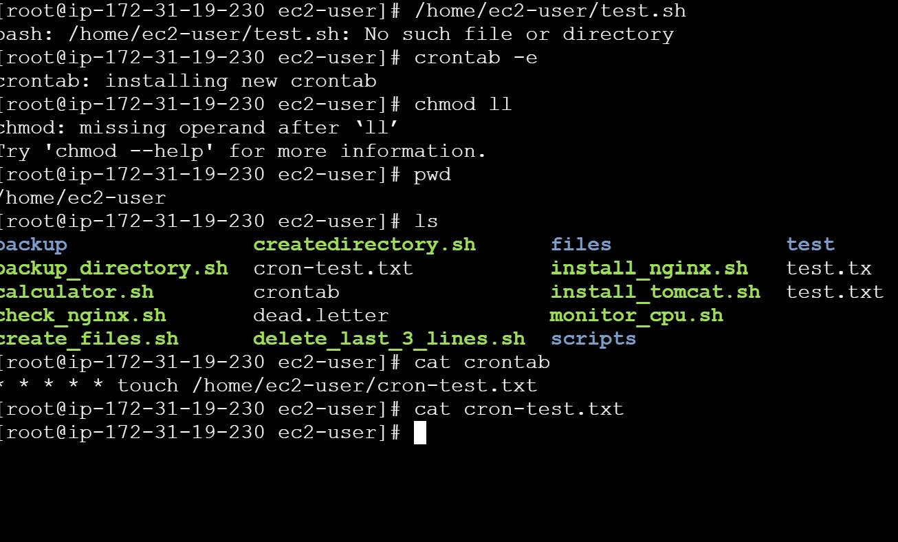
sudo systemctl start crond
sudo systemctl enable crond
Important: For production monitoring, CPU/memory/disk email alerts are usually better implemented with Amazon CloudWatch + SNS on EC2, rather than relying only on local mail.
create a word document
It seems like I can’t do more advanced data analysis right now. Please try again later.
I was unable to invoke the document-generation tool, so I can't create the downloadable Word document at this moment.
You’re out of data analysis for now. Start a free Plus trial for more, or try again tomorrow after 10:29 AM.
Try Plus free

